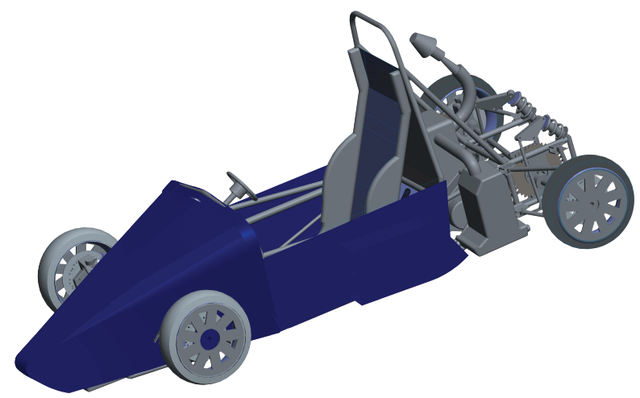

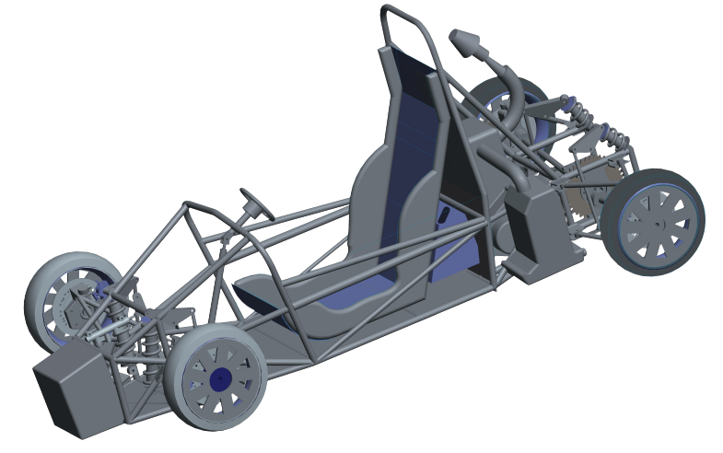

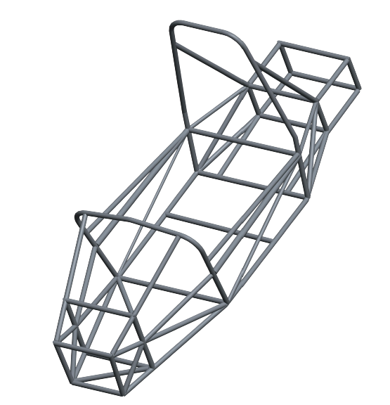

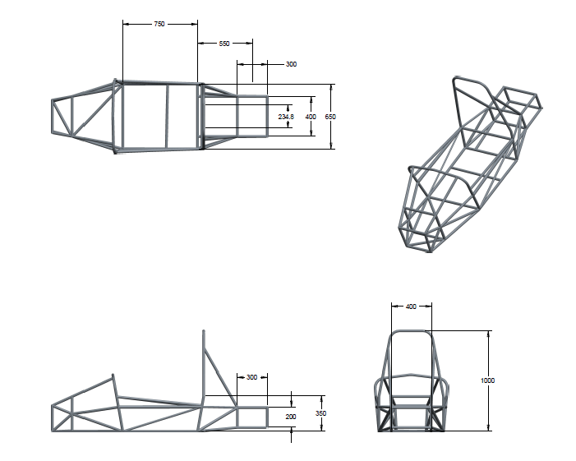

Paper Number 01

IMPULSIFIERS Chassis Design

Mr. Mahendra Singh Sengar

Vice- Captain, IMPULSIFIERS

Miss. Shyamlee S. Mishra

**Mr. Mitheshwar Thombre**

Mr. Prabhat Rajput

Members, IMPULSIFIERS

Copyright © 2015 IMPULSIFIER

Abstract

This paper is an introduction to the design methodology, factors and the objectives that has to be attained in F1 type vehicle. It also includes all the safety considerations that are made in a vehicle design, detailing the analysis required for the same. Fabrication plan and considerations are equally important. Thus, this paper is an overview of such considerations.

**INTRODUCTION**

The STUDENT FORMULA competitions challenge teams of university undergraduate and graduate students to conceive, design, fabricate, develop and compete with small, formula style, vehicles. The Formula SAE competition requires the construction of an f1 type vehicle for weekend racers that should be cost efficient and safe. The roll cage is designed in order to attain minimum weight at optimum cost and time for fabrication. It meets all the requirements specified in the rulebook. It has lower center of gravity to attain maximum possible stability while not compromising on safety. Also ergonomic study of the design has been done to optimize driver comfort and his reach to all drive controls.

**DESIGN FACTORS, DESIGN CRITERIA, CALCULATION, DIMENSIONS/SPECIFICATIONS**

**Design Factors**

The design factors for the chassis are as follows-

* Push rod rear suspension, Push rod front suspension
* Carry pre-determined suspension points
* Allow space for engine, intake, exhaust, cooling
* Have 54% rear weight bias
* Hold all electronics within chassis structure
* Lower centre of gravity
* Keep components as close to car centre line as possible
* Shallower seat angle for lower driver CG
* Minimum torsional stiffness of 600N-m/deg in ANSYS analysis
* Weigh less than 45kg
* Least head clearance of 2 inches for all the drivers
* Conform to 2015 SAE chassis rules

**Design Criteria**

* Least Wheelbase of 60 inches
* The smaller track of the vehicle (front or rear) should be least 75% of the larger track.
* Visible access
* Suiting 95 percentile male & 5 percentile female criteria

**Material Criteria**

As per the rulebook, following criteria must be followed:

Steel tubing (minimum 0.1% carbon) of least dimensions of Round 1.0 inch (25.4 mm) x 0.095 inch (2.4 mm) thickness.

Least bending and buckling strength:

* Young's Modulus (E) = 200 GPa
* Yield Strength (Sy) = 305 MPa
* Ultimate Strength (Su) = 365 MPa

Welded tube joint strength:

* Yield Strength (Sy) = 180 MPa (26ksi)
* Ultimate Strength (Su) = 300 MPa (43.5 ksi).

**Calculations**

Frontal and rear impact (@80 km/h)

=m* (v1-v2) / t

=280 * (22.22-0) / 0.2

=31111

͌ 30000 N =10.91g

Side impacts Load = 22000 N = 8g

**Brake force on axles:**



Therefore,

**F bfmax** = 0.7*360*9.81(0.77+0.25(0.7+0.02))/1.80

=**1304.73 N**

**F brmax** =

0.7*360*9.81(1.03-0.25(0.7+0.02))/1.80

=**1167.39 N**

**Ergonomics Study**

The ergonomics of a cockpit for vehicle is very important. If the vehicle controls are not strategically placed the operator will have difficulty in operating vehicle. Keeping all these parameters in mind we made a wooden prototype which helped us in solving all ergonomic difficulties and to find out the exact dimensions according to the criteria of 95% male and 5% female.

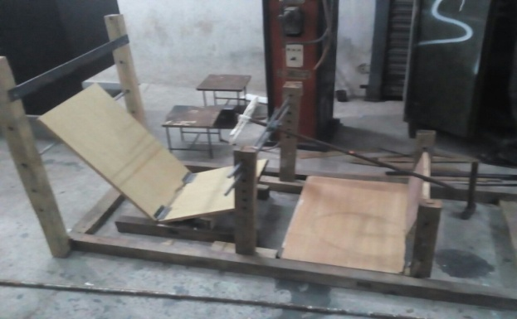

Fig.1 Wooden Prototype

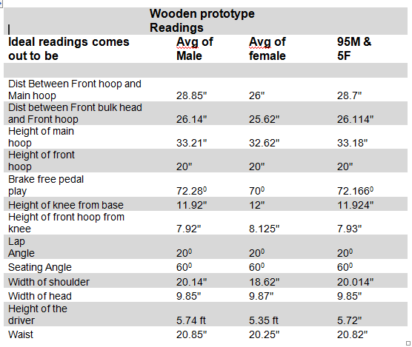

Fig.2 Readings

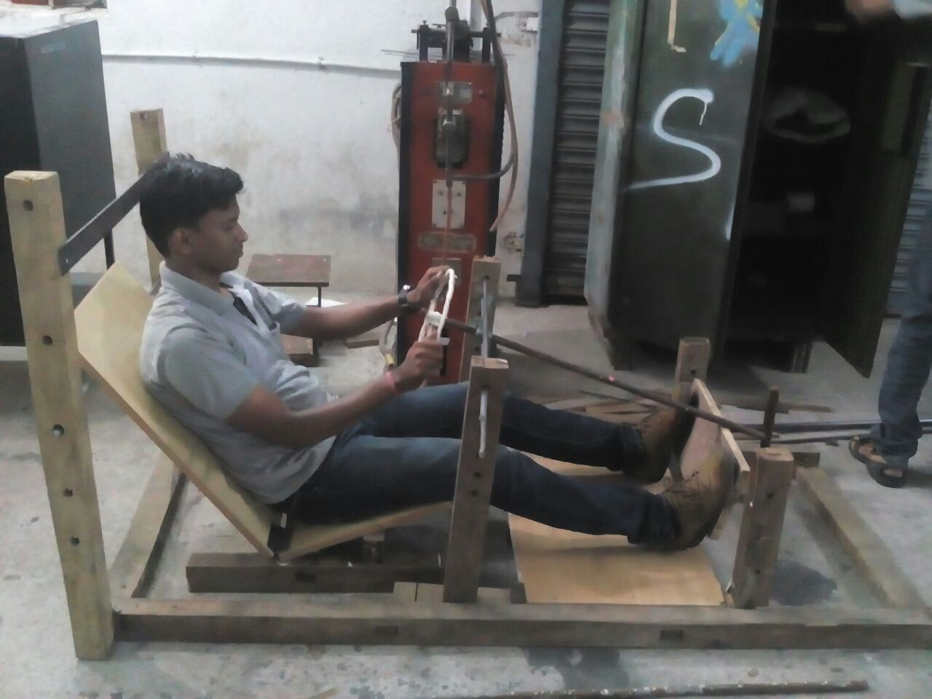

**Prototype of the Chassis**

Prototyping was made to check the dimensions proving appropriate accordance to the rules. Prototype of PVC has been made by making it contour dimensions which have been made and checked in CREO-2.0 & ANSYS respectively.

Our prototype meets the exact dimensions. And the doubts regarding our dimensions got cleared.

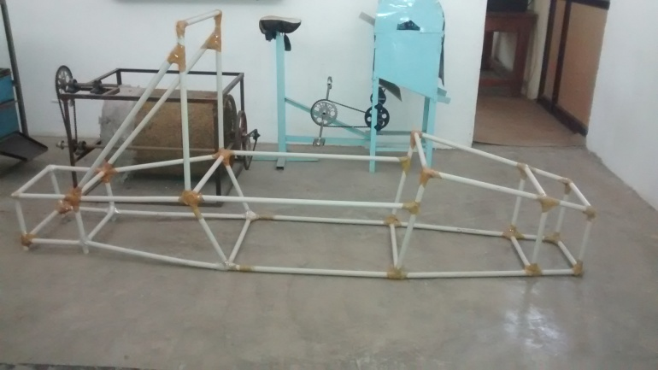

Figure no. 3 Prototype of the chassis

**Chassis Specification**

Vehicle Dimensions

Wheelbase = 1800mm

Wheel track = 1200mm

Total height = 1080mm

Cockpit section is 650*750mm

Front hoop height 550mm

Main hoop height 1000mm

Weight = 38kg

Coefficient of Drag= 0.3

**Material Details**

Density - 7.758 g/cm3 (488.744 lb/ft3 )

Modulus of Elasticity - 205 GPa (30 x 106 psi)

Ultimate Tensile Strength - 440 MPa

Tensile Yield Strength: - 370 MPa

Templates of specified dimensions have been made and it has made sure if chassis dimensions has complied all the rules.

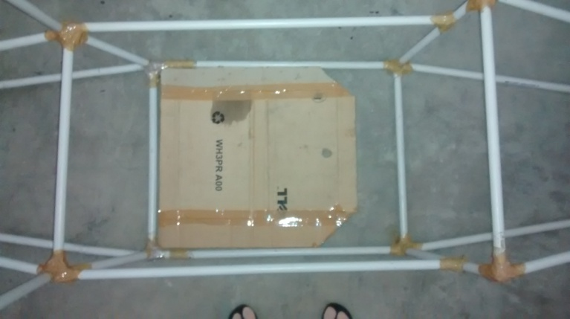

Figure No. 4 Cockpit Template

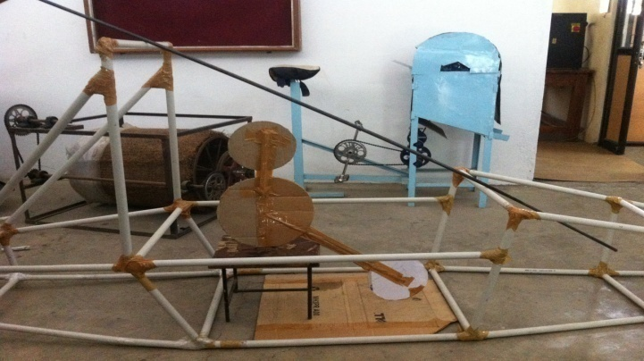

Figure No. 5 Driver Template

**Welding calculation**

For equal strength in a pipe and a joint the stresses in a pipe and joint must be equal

i.e., P/A= P/A’

Where

P = load acting on a pipe

A = area of pipe

A’ = area of weld joint

* 4/( d2-d12)= 1/d*t
* t = (d2 – d12 )/ (d*4)
* ((25.4)2 – (20.06)2) / (25.4*4)
* 2.38 mm

Thus thickness of weld was found to be **2.38 mm.**

**Analysis of Chassis**

Much like any mechanical design, this chassis must undergo analysis to determine if it meets its strength and stiffness goals. The analysis tool that IMPULSIFIERS uses is ANSYS for finite element modeling and analysis. It is important to outline the procedure for using ANSYS so that iterations may be performed quickly and smoothly. Chassis of the intricate dimensions have been checked for various stresses in ANSYS.

Chassis is the most critical part of a vehicle subjected to different force in different running conditions. Thus, software analysis of the chassis is done for different running conditions to check the response of the chassis under different loads ensuring that the chassis is strong enough to bear all the types of load. ANSYS APDL 14.5 is used for analysis of chassis in frontal impact, rear and side impact, conditions like braking, acceleration and cornering are also considered and respective calculated forces are applied on chassis to see that the deflection and stresses are in limit. Ansys APDL features easy plotting of coordinates and adding and removal of links.

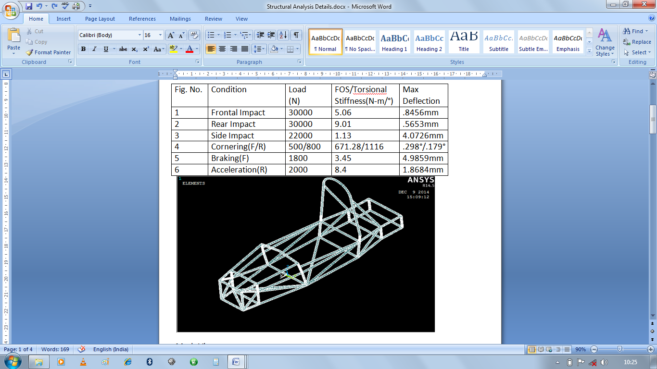

Fig No. 6 Table showing readings

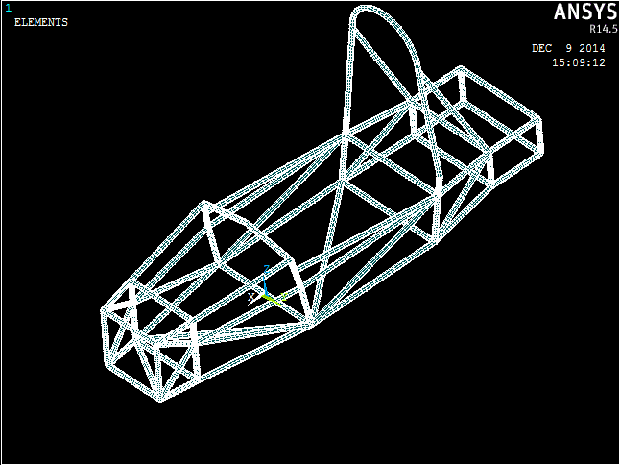

Figure No.A.0. Mesh View

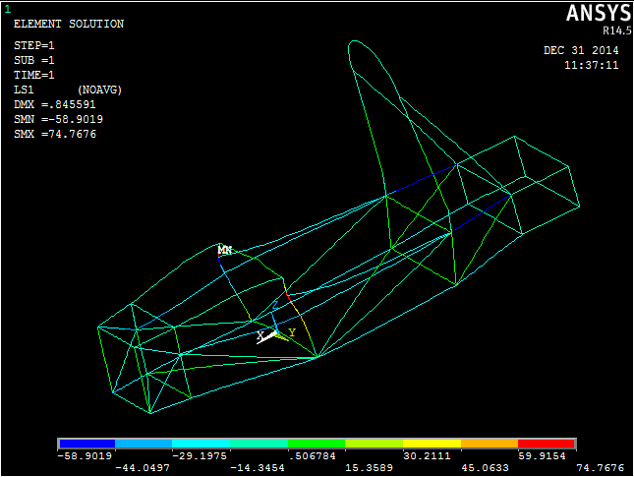

Figure No.A.1. Front Impact

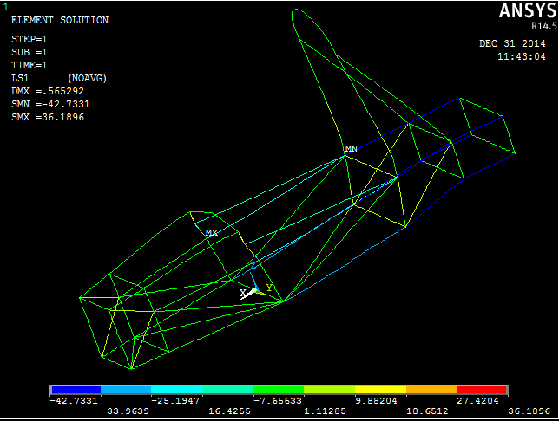

Figure No.A.2.Rear Impact

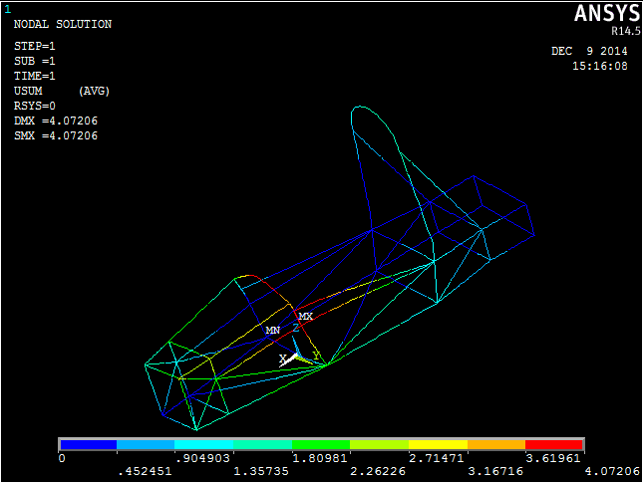

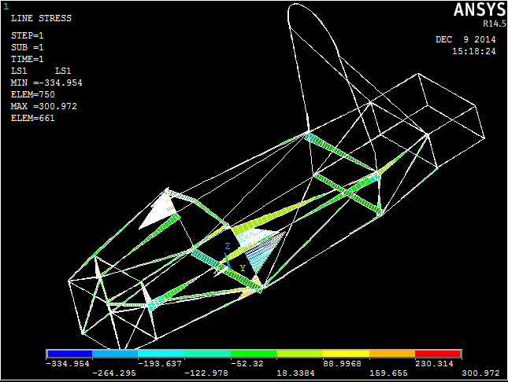

Figure No.A.3. Side Impact

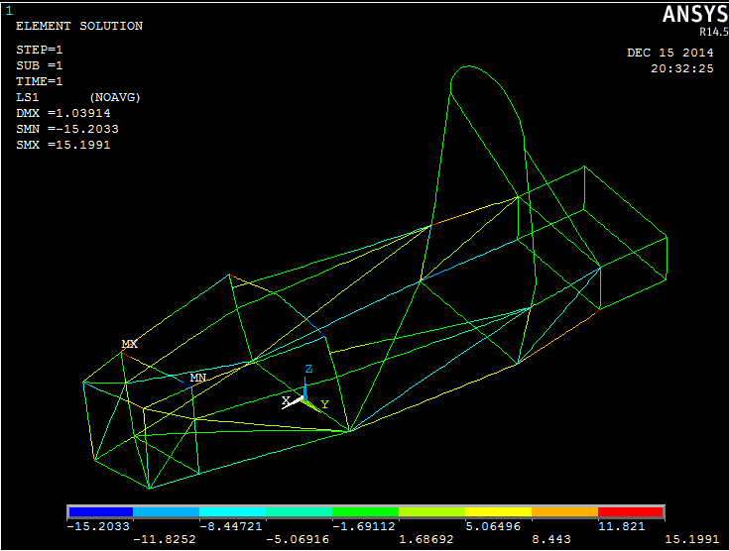

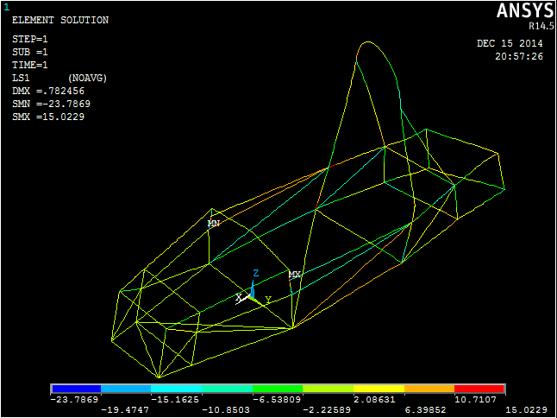

Figure No.A.5. Cornering (Front/ Rear)

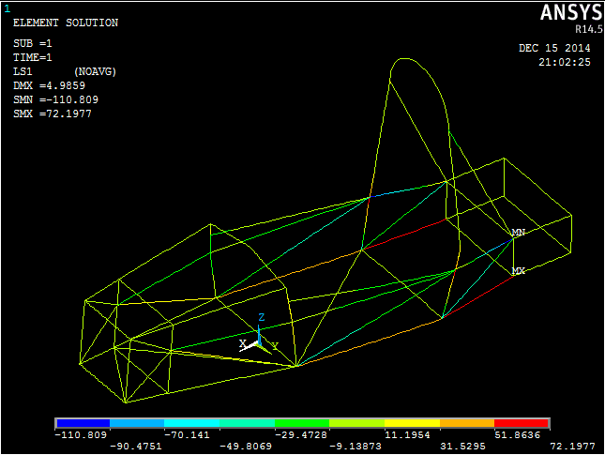

Figure No.A.6. Braking Front

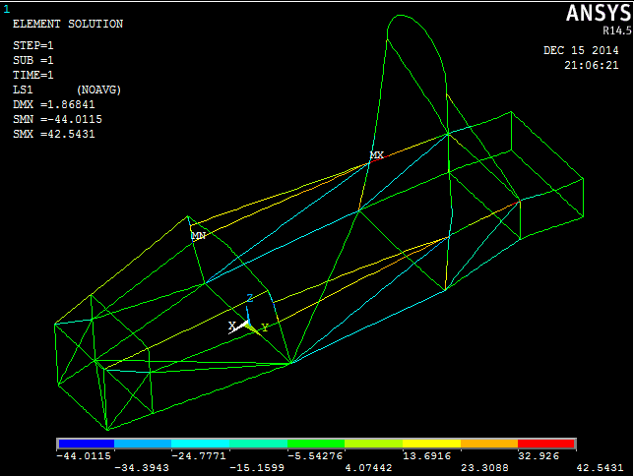

Figure No.A.7 Acceleration Rear

**Analysis of the solid car model for coefficient of drag**

**Solver-** ANSYS FLUENT

**Solver Specifications-**

Type -> pressure based & velocity formulation- absolute

Time -> steady

Viscous model-> k-epsilon

K-epsilon model-> Realizable

Near wall treatment-> Non equilibrium wall function

**Analysis Boundary Conditions-**

Inlet Velocity-> 33m/s (at the entry of wind tunnel)

Outlet pressure-> 1.01325*105 Pascal (at the exit of wind tunnel)

**Solution Methods-**

Pressure-Velocity Coupling Scheme-> simple

Spatial Discretization

Gradient-> Least Square cell based

Pressure-> Standard and second order

Momentum-> First order upwind and second order upwind

Turbulent Kinetic Energy-> First order upwind and second order upwind

Turbulent Dissipation Rate-> First order upwind and second order upwind

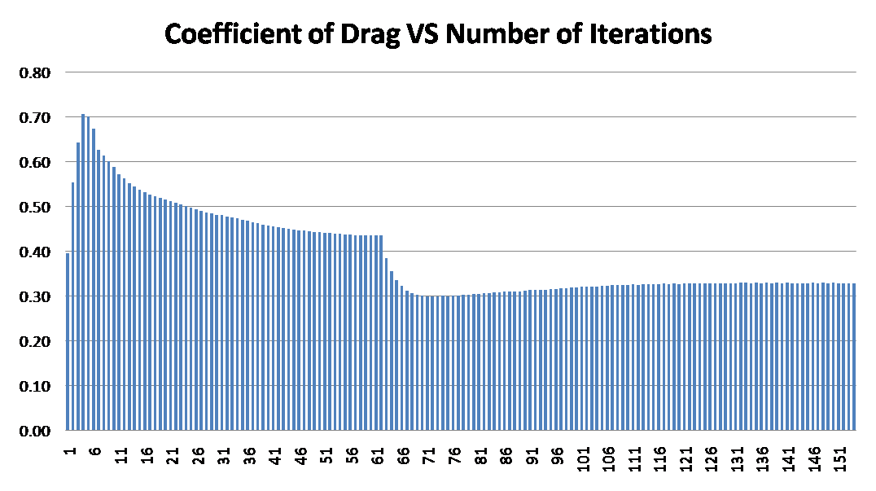

**Results-> coefficient of drag was found to be 0.32 in second order iteration**

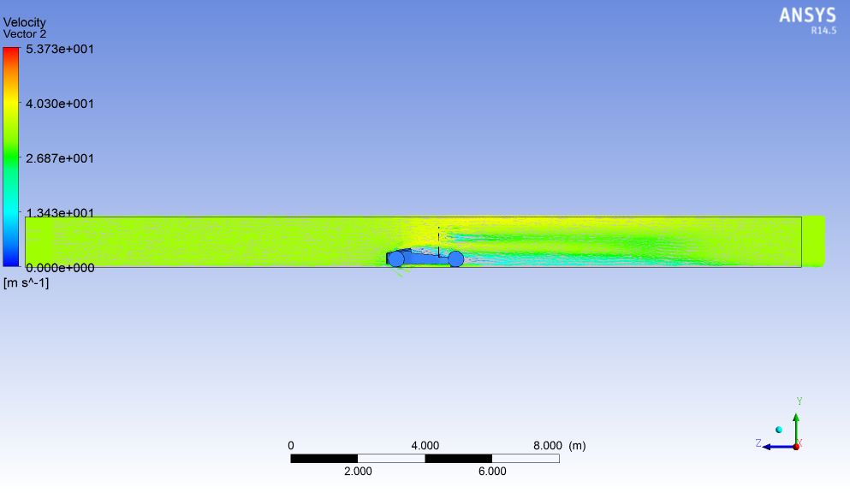

velocity vector (on vertical plane)

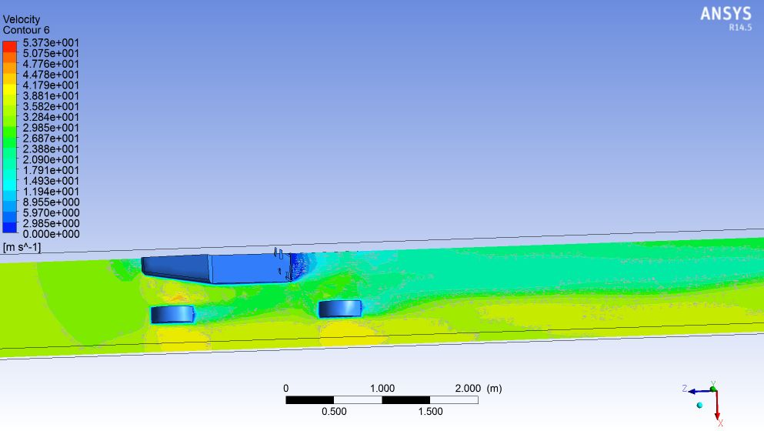

velocity contour (on horizontal plane)

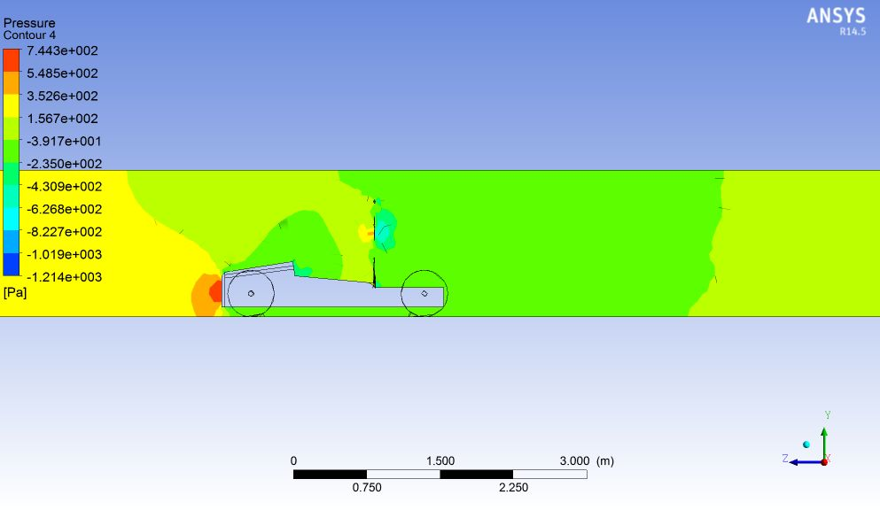

Pressure contour

**Cockpit**

The cockpit is the first section to be built on the frame. This section is built first so that it can be used as a template for seat construction. The side impact structure of the cockpit must be built from the bottom toward the top so that during tube notching and fitment, a tight fit may be achieved for each tube.

**CONCLUSION**

The chassis is designed and tested for different running conditions on the software and it is found safe for the driver. It is compatible to fit all the systems in the vehicle and can sustain various loads coming on the chassis. It is designed to withstand different impacts i.e. front, rear and side impact force. Also the forces acting on the chassis due to different running conditions are applied to subjected points and are tested for the same on Ansys. Ergonomic study was carried out successfully and fits in all the ergonomic requirements.

To finish the chassis by a deadline that is put in place by the team, the designer needs to have his/her design fully completed and frozen by the time construction starts. Changing design points during fabrication can significantly hinder progress because days or even weeks will go by without any construction while the designer is modifying their model. This can decrease team morale and motivation to finish the project.

**ACKNOWLEDGEMENT**

The authors would like to thank Prof. R. U. Patil, Prof. S. S. Naidu, Prof. B. C. Bissa and the rest of the IMPULSIFIERS and professors of RCOEM, Nagpur for their valuable support and advice during the project.

**REFERENCES**

* <http://suprasaeindia.org/>
* <http://suprasaeindia.org/download.html>
* <http://suprasaeindia.org/discussion-forum.html>
* <https://www.google.co.in/url?sa=t&rct=j&q=&esrc=s&source=web&cd=1&cad=rja&uact=8&ved=0CBwQFjAA&url=http%3A%2F%2Fteamsrijan.com%2Fdocuments%2Freport.pdf&ei=pFCqVKbuBZKcugSz2IKICg&usg=AFQjCNHNz8VWE9a8SdTBSSYi9QhLKNfOig>
* <http://www.viit.ac.in/uploaded%20files/SAE%20INDIA%20Supra%202014.pdf>
* <http://www.velammaltrust.com/pdf/SUPERNOVA.pdf>





|  |  |  |  |  |  |  |  |  |  |  |  |  |  |
| --- | --- | --- | --- | --- | --- | --- | --- | --- | --- | --- | --- | --- | --- |
| Sr no. | FH-MH | FBH-FH | Ht of MH | Ht of FH | Knee Ht | knee- MH | Lap angle | Back angle | Shoulder | Head | Waist | Height of driver(feet) | |
| 1 | 35" | 25" | 34" | 20" | 11" | 8" | 20deg | 60deg | 21" | 8" | 23" | 6.1 |  |
| 2 | 26" | 27" | 34" | 20" | 111" | 8.3" | 20deg | 60deg | 18" | 8" | 19" | 5.75 |  |
| 3 | 35" | 26" | 33" | 20" | 11" | 7.5" | 20deg | 60deg | 19" | 8.75" | 21" | 5.8 |  |
| 4 | 29" | 25.5" | 32" | 20" | 11" | 8" | 20deg | 60deg | 23" | 8" | 21" | 5.6 |  |
| 5 | 25" | 26" | 35" | 20" | 12" | 8" | 20deg | 60deg | 245" | 7.7" | 21" | 6.1 |  |
| 6 | 34" | 24" | 32" | 20" | 13" | 6.75" | 20deg | 60deg | 23" | 9.5" | 18" | 5.7 |  |
| 7 | 26" | 27" | 34" | 20" | 12" | 6" | 20deg | 60deg | 22" | 10" | 21" | 5.7 |  |
| 8 | 27" | 28" | 32" | 20" | 12" | 7" | 20deg | 60deg | 22" | 7" | 18" | 5.4 |  |
| 9 | 29" | 26" | 32.6" | 20" | 12" | 7" | 20deg | 60deg | 21" | 7.8" | 20" | 5.9 |  |
| 10 | 30" | 24" | 34" | 20" | 11.5" | 8" | 20deg | 60deg | 20.5" | 8" | 21" | 5.11 |  |
| 11 | 31" | 27" | 33" | 20" | 12.5" | 6.7" | 20deg | 60deg | 26" | 9.2" | 20" | 5.11 |  |
| 12 | 25" | 24.5" | 34" | 20" | 11" | 7.5" | 20deg | 60deg | 27" | 9.4" | 23" | 5.5 |  |
| 13 | 29" | 25" | 35" | 20" | 11" | 6.3" | 20deg | 60deg | 30" | 10.2" | 22" | 5.11 |  |
| 14 | 26" | 26" | 36" | 20" | 11" | 7" | 20deg | 60deg | 31" | 7.8" | 23" | 6.2 |  |
| 15 | 35" | 28" | 34.5" | 20" | 11.5" | 7.2" | 20deg | 60deg | 22" | 8.4" | 19" | 5.9 |  |
| 16 | 36" | 24.5" | 34" | 20" | 11.25" | 6.7" | 20deg | 60deg | 18" | 6.3" | 21" | 5.9 |  |
| 17 | 31" | 23.5" | 33.75" | 20" | 12" | 7.5" | 20deg | 60deg | 19" | 8.9" | 21" | 5.8 |  |
| 18 | 27" | 25" | 34" | 20" | 12" | 7.3" | 20deg | 60deg | 22" | 8.1" | 24" | 5.9 |  |
| 19 | 34" | 27" | 35" | 20" | 13" | 8.2" | 20deg | 60deg | 31" | 9.3" | 31" | 5.11 |  |
| 20 | 32" | 26" | 34" | 20" | 11" | 8" | 20deg | 60deg | 25" | 8.7" | 34" | 6.1 |  |
| 21 | 32" | 26.5" | 35" | 20" | 10" | 7" | 20deg | 60deg | 27" | 7.9" | 19" | 5.9 |  |
| 22 | 32" | 24" | 35" | 20" | 11.75" | 7.5" | 20deg | 60deg | 26" | 9" | 21" | 5.1 |  |
| 23 | 32" | 24" | 36" | 20" | 12" | 7.3" | 20deg | 60deg | 28" | 8.7" | 18" | 5.1 |  |
| 24 | 27" | 24" | 35.6" | 20" | 13" | 7.75" | 20deg | 60deg | 22" | 9.1" | 20" | 5.7 |  |
| 25 | 25" | 23.75" | 35" | 20" | 12.5" | 7.2" | 20deg | 60deg | 23" | 10" | 29" | 5.4 |  |
| 26 | 29" | 26" | 36" | 20" | 12.2" | 7.3" | 20deg | 60deg | 19" | 1.3" | 25" | 5.1 |  |
| 27 | 20" | 26.25" | 34" | 20" | 13" | 7" | 20deg | 60deg | 21" | 9.8" | 22" | 5.11 |  |
| 28 | 19" | 27" | 34" | 20" | 11.7" | 6.7" | 20deg | 60deg | 15" | 7.1" | 23" | 5.1 |  |
| 29 | 34" | 26" | 34" | 20" | 11.3" | 7.7" | 20deg | 60deg | 19" | 8.1" | 25" | 6 |  |
| 30 | 24" | 26" | 34" | 20" | 13" | 8.3" | 20deg | 60deg | 31" | 7" | 21" | 5.9 |  |
| 31 | 25" | 23" | 34" | 20" | 14" | 9" | 20deg | 60deg | 28" | 8" | 19" | 5.9 |  |
| 32 | 35" | 23" | 35" | 20" | 12" | 9.1" | 20deg | 60deg | 22" | 8" | 24" | 5.8 |  |
| 33 | 34" | 24" | 34" | 20" | 12" | 6.2" | 20deg | 60deg | 18" | 8" | 19" | 5.11 |  |
| 34 | 25" | 25" | 35" | 20" | 12" | 8.75" | 20deg | 60deg | 31" | 8" | 20" | 5.7 |  |
| 35 | 26" | 26" | 35" | 20" | 12" | 6.9" | 20deg | 60deg | 27" | 9.5" | 25" | 5.9 |  |
| 36 | 27" | 26" | 34" | 20" | 11" | 7.5" | 20deg | 60deg | 22" | 10.2" | 26" | 5.1 |  |
| 37 | 34" | 26" | 35.5" | 20" | 11" | 12.5" | 20deg | 60deg | 22" | 8.9" | 24" | 6 |  |
| 38 | 24" | 27" | 35.75" | 20" | 11" | 10.1" | 20deg | 60deg | 22" | 7.8" | 23" | 5.11 |  |
| 39 | 24" | 23" | 35" | 20" | 11" | 7.85" | 20deg | 60deg | 22" | 8.4" | 21" | 5.7 |  |
| 40 | 23" | 24" | 36" | 20" | 11" | 6.0" | 20deg | 60deg | 22" | 6,7" | 20" | 5.9 |  |
| 41 | 34" | 25" | 35" | 20" | 11" | 9.5" | 20deg | 60deg | 22" | 8.6" | 31" | 5.9 |  |
| 42 | 20" | 26" | 35" | 20" | 11.75" | 7.8" | 20deg | 60deg | 18" | 7.8" | 29" | 5.9 |  |
| 43 | 35" | 25" | 34.5" | 20" | 11.5" | 7.0" | 20deg | 60deg | 29" | 8.7" | 24" | 6 |  |
| 44 | 19" | 24.5" | 35" | 20" | 12" | 7.8" | 20deg | 60deg | 19" | 8" | 24.5" | 5.11 |  |
| 45 | 31" | 29" | 35" | 20" | 12" | 8" | 20deg | 60deg | 26" | 8" | 26" | 5.1 |  |
| 46 | 27" | 24" | 34.5" | 20" | 12" | 8.7" | 20deg | **60deg** | 24" | 8" | 27" | 5.9 |  |
| 47 | 27" | 26" | 33.5" | 20" | 13.1" | 9.1" | 20deg | 60deg | 28" | 8" | 24" | 5.11 |  |
| 48 | 31" | 24.75" | 36" | 20" | 12.5" | 8.3" | 20deg | 60deg | 22" | 8" | 25" | 5.11 |  |
| 49 | 35" | 24.75" | 36" | 20" | 11.8" | 9.1" | 20deg | 60deg | 22" | 9.4" | 21" | 5.8 |  |
| 50 | 29" | 24" | 35" | 20" | 12" | 8.5" | 20deg | 60deg | 22" | 9.7" | 19" | 5.5 |  |
|  |  |  |  |  |  |  |  |  |  |  |  |  |  |
|  |  |  |  |  |  |  |  |  |  |  |  |  |  |